

Trainee Name

Dip(T) IPEM: Portfolio

Introduction

Introduce yourself and your portfolio

Table of Contents

Introduction 2
Competency matrix 5
Training Plan 6
Legislation 7
1.1 IR(ME)R 7
1.2 IRR17 7
1.3 ARSAC 7
1.4 Other 7
Radiation safety and theory 8
1.1 Time, Distance and Shielding 8
1.2 Nuclear medicine physics 8
1.3 Radioactive spills 8
1.4 Other 8
Equipment/Instrumentation 9
1.1 Gamma Camera 9
1.2 CZT technology 9
1.3 CT 9
1.4 Contamination monitors 9
1.5 Gamma probes 9
1.6 Gamma counter 9
1.7 Other 9
Clinical Practice 10
1.1 Skeletal Imaging 10
1.2 Renal imaging 10
1.3 Gastric/digestive system imaging 10
1.4 Hepatobiliary imaging 10
1.5 Pulmonary imaging 10
1.6 Endocrine imaging 10
1.7 Infection imaging 10
1.8 Tumour imaging 10
1.9 Lymphatic imaging 10
1.10 Neuro imaging 10
1.11 Cardiac imaging 10
1.12 Other 10
Non-Imaging 11
1.1 GFR 11
1.2 Cell labelling 11
1.3 Other 11
PET-CT 12
Theranostics 13
Experiments 14
Clinical governance 15
General anatomy and physiology 16
Short cases 17
Extended (Long) case studies 19
Log of experience 20
Reflective diary 21
Direct Observation of Practical Skills (DOPs) 22
External moderator 23
Training forms 24
Certificates of achievement 25

Competency matrix
 | Competency matrix | Competency Forms
1 | Core competency, Statutory and mandatory, patient confidentiality, data protection, infection control, moving and handling, Basic Life Support & in-hospital resuscitation et al
2 | Legislation (IRMER, IRR, Waste disposal etc.) Employers procedures, Incident reporting
3 | CRIS (Reception duties, Appointments, Paperwork, General, Processing)
4 | Radiopharmaceutical preparation and dispensing
5 | Radiopharmaceutical administration and Venepuncture and cannulation
6 | Gamma camera practical operation
7 | QC (Daily, weekly, periodic)
8 | Computing analysis (ie Hermes, Xeleris, 4DM, image processing)
9 | SPECT and SPECT-CT
10 | Skeletal imaging
11 | Pulmonary imaging
12 | Hepatobiliary and Digestive system imaging
13 | Renal Imaging
14 | Neuro Imaging
15 | Cardiac Imaging
16 | Tumour imaging
17 | Infection imaging
18 | Endocrine imaging
19 | Non-imaging (cell labelling, GFR, gamma counter, probes etc.)
20 | Radiopharmacy
21 | Paediatrics
22 | PET-CT
23 | Theranostics and radiobiology

Training Plan

Attach your agreed training plan here

Legislation

Provide a write up on each of the important pieces aspects of legislation in nuclear medicine

IR(ME)R

IRR17

ARSAC

1.4 Other

Radiation safety and theory

Time, Distance and Shielding

Fundamentals of radiation protection and their importance

Nuclear medicine physics

A good section on the theoretical side of nuclear medicine physics

Radioactive spills

Dealing with a spill; how do you deal with a radioactive spill/contamination? What if it involves a patient? Do different isotopes change your approach? Etc.

1.4 Other

Equipment/Instrumentation

Gamma Camera

CZT technology

CT

Contamination monitors

1.5 Gamma probes

1.6 Gamma counter

1.7 Other

Clinical Practice

Skeletal Imaging

Renal imaging

Gastric/digestive system imaging

Hepatobiliary imaging

Pulmonary imaging

Endocrine imaging

Infection imaging

Tumour imaging

Lymphatic imaging

Neuro imaging

Cardiac imaging

Other

This section is looking to include a detailed write up for each study you encounter in your training. Again keep it relevant.
I.e., endocrine imaging section: create sub sections and have nice clear write ups on 1) Thyroid uptake scan, a nice write up on 2) parathyroid imaging etc. etc.…….. look to include as an EXAMPLE format (THIS IS BY NO MEANS RESTRICTIVE, your own approach and style is encouraged; this is a key part of the discussions you will have with your external moderator and training supervisor, however, this is a useful guide to get you on track…..
Example content…..
What is a Thyroid uptake scan? What are the common clinical indications for a thyroid uptake scan? What is the radiopharmaceutical(s) used? What are the ARSAC limits (And relevant DRL’s for your place of practice?), how do you carry out the study from a technologist perspective? Camera preparation and set up; do you have to carry out a standard acquisition prior to starting the study? If so, why? What collimators are you using and why? What type of imaging is being performed, ie dynamic, SPECT-CT etc., what patient preparations are required prior to carrying out the study? Is there image processing required post study? The write ups can also be hyperlinked nicely to your ‘Anatomy and physiology’ section. You can also hyperlink this section to the relevant short case studies. Keep the portfolio flowing and connected!

Non-Imaging

GFR

Cell labelling

1.3 Other

PET-CT

Theranostics

Experiments

Example – Williams phantom (Resolution in depth).

Discuss with your physics staff, the possibilities for experimentations

Clinical governance

Write ups about, and evidence of the following:

Examples: Clinical audits, Risk assessments, Incident reports, CPD, etc.

General anatomy and physiology

Some detailed write up’s on general anatomy and physiology. A useful approach may be to do individual sections for each of the main body systems i.e., ‘’the urinary system’’, which can then be hyperlinked from the relevant write ups for a particular scan, for example, in your write up on renograms, hyperlink to your section on the urinary system.

Short cases
QUALITY OVER QUANTITY! – provide cases relative to the common clinical indications for each study. For example;
VQ studies:
- Normal study
- P.E
- R>L shunt There are no prizes for showing 10 examples of Pulmonary embolism + 5 normal studies!
- LVRS
- Rare scan/oddities

Gastric emptying:
- Normal emptying
- Gastroparesis Again, no prizes for showing 10 cases of gastroparesis and 5 normal studies!
- Dumping
- Unique case(s)

Always look to include unique or rare scans that you observe during your training.
EXAMPLE – Not the only way to go about it, but below is an example of a succinct short case (Including acquisition parameters, images, clinical history/indications, your own impression, report).

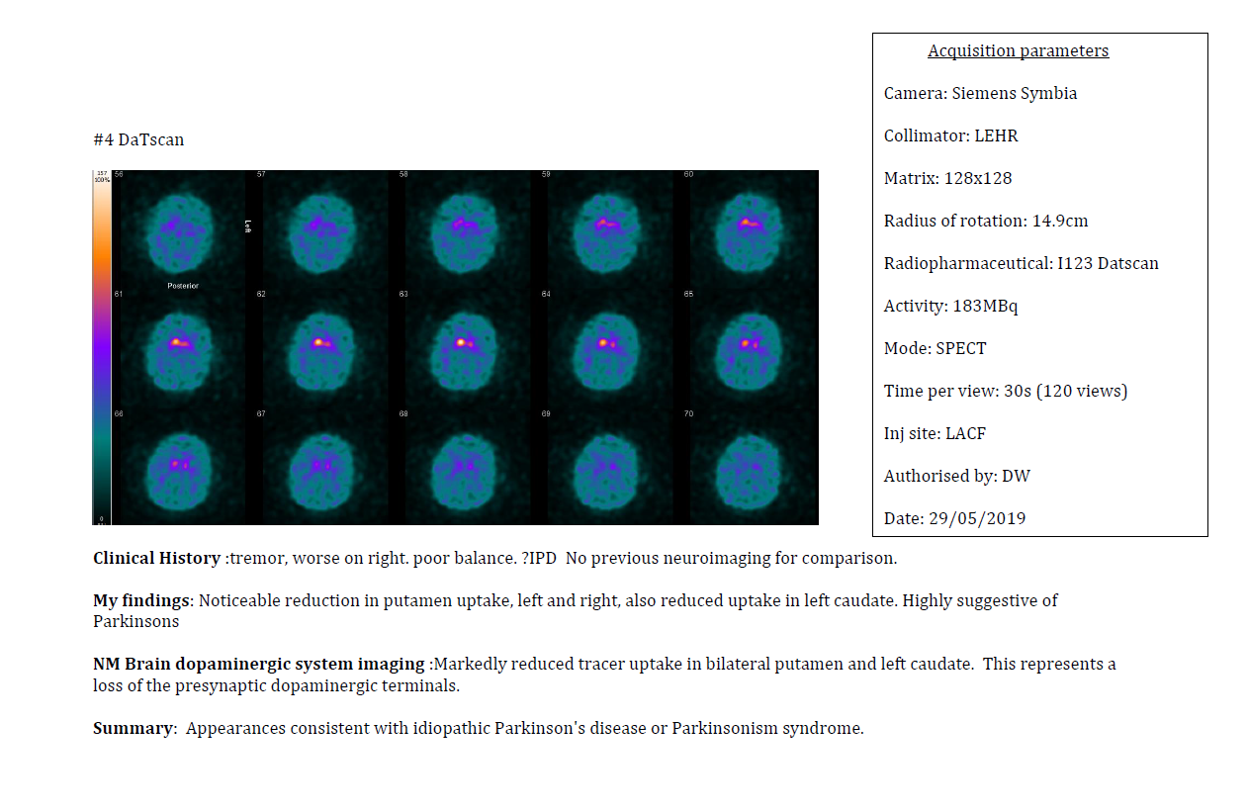

Extended (Long) case studies

Provide 2 extended long case studies. This is a significant part of your portfolio (They make up 25% of your total portfolio grade!).

Look to choose 2 DIFFERENT subject areas, one for each long case – i.e. 1) Cardiac based long case, 2) PET-CT based long case etc. – the list of possibilities is extensive. Discuss with your training superior, find good patient examples (Could be a rare pathology, unique case, or something that simply is of interest to you the trainee, and you have played a crucial role in the patient pathway).

A minimum of 3,000 words, extended case study – a deep dive in a patient pathology & pathway –
Patient background, multi-modality, diagnosis, treatment plan, what is the treatment for the pathology, response to treatment, patient outcomes, your involvement in the pathway, the importance of nuclear medicine...

Log of experience
This table can be used to log and document your experience. It can be useful to highlight interesting scans, key information, track progress and make it easy to identify your short case study candidates. A couple of examples have been included in the table below….
Task: Record of Nuclear medicine scans
Date | Scan Type | Comments | Scan/study identifier | Supervisor Signature
DD/MM/YY | Whole body bone scan | LEHR collimators, Tc99m HDP 613MBq, 256x256, GE optima camera, SPECT-CT was requested.
DD/MM/YY | Lung VQ | Technegas, half activity MAA, LEGP collimators, pregnant patient to investigate possible PE, perfusion count rate; X ventilation count rate; Y
 |  | .

Reflective diary

Another hugely important part of your portfolio (Worth 20% of your overall portfolio grade!) To complete your reflections, it is useful to follow a structured template, such as the Gibbs reflective cycle, or the reflective template that IPEM have available for all trainees (Appendix 1: Technologists handbook p.39). Look to complete a reflection on a one a week basis – At the beginning of your training you will be writing more detailed reflections as you carry out things for the first time, first experiences etc., as you progress and gain more experience your reflections will likely take on a more succinct approach. Below is an example using a reflection using a cycle/template approach…..THIS CAN BE AS DETAILED OR AS SUCCINCT AS YOU DESIRE – DISCUSS WITH YOUR EXTERNAL MODERATOR ON PREFERENCE.

Event/skill: Carrying out my first Bone Scan Date DD/MM/YY

- Description: After spending a period of time watching senior staff, asking questions and learning about bone scans, I was asked to carry out my first whole bone scan from start to finish. I was asked to carry out the scan under the supervision and guidance of X (senior tech).

- Feelings: Naturally, I was a bit nervous and apprehensive. Even though X made me feel extremely comfortable and relaxed, I still felt a bit nervous and didn’t want to make a mess of my explanation to the patient or in my operation of the camera.

- Evaluation: In spite of my nerves, I was able to successfully identify the patient, explain the scan to them, position them on the bed, and then successfully carry out the scan.

- Analysis: By following X’s advice and having had plenty of time to observe other members of staff and how they go about working, I feel it helped me a lot and made me feel capable of carrying out the scan successfully.

- Conclusion: I realise that I need more practice, as I almost forgot to ask the patient to remove their belt and empty their pockets. I only realised this whilst I was taking the patient over to the bed. This is something that I will reinforce through practice. But for my first Scan, I feel it went well, and helped my confidence a lot. I am looking forward to doing more of them in the coming days to continue to practice the process and continue to develop my confidence in explaining the scan to patients.

Direct Observation of Practical Skills (DOPs)

INSERT YOUR DOPs FORMS INTO YOUR PORTFOLIO HERE

Aim to carry out a DOPs one per month – this is a crucial part of your on-going assessment of practical competency and understanding. Ensure your training supervisor is carrying these out when appropriate. DOPs contribute towards your overall practical grade.

External moderator

Use this section for E.M documentation – i.e. First practical assessment DOP’s etc.

Training forms

Attach your signed and completed training forms here – These can be hyperlinked from your competency matrix, to enable easy access and navigation for moderators to ensure competency has been met. Can also hyperlink training forms from write ups/case studies etc.…

Certificates of achievement

Attach your certificates of achievements here – they can be hyperlinked from the main body of your portfolio.

